Calculating Watersheds for Frijoles:

Working in Project **CapulinFrijolesDEM.aprx** and primarily in **WatershedsAlpha.gdb**

Download from “3DEP LidarExplorer” https://prd-tnm.s3.amazonaws.com/LidarExplorer/index.html#/

mosaic together 2016 DEMs

I queried Bandelier National Monument as AOI and downloaded the following DEMs that overlapped the Frijoles and Capulin Watersheds:

USGS_one_meter_x37y397_NM_NorthCentral_B2_2016.tif

USGS_one_meter_x37y397_NM_NorthCentral_B2_2016.tif

USGS_one_meter_x37y398_NM_NorthCentral_B2_2016.tif

USGS_one_meter_x38y396_NM_NorthCentral_B2_2016.tif

USGS_one_meter_x38y397_NM_NorthCentral_B2_2016.tif

“Mosaic to New Raster”

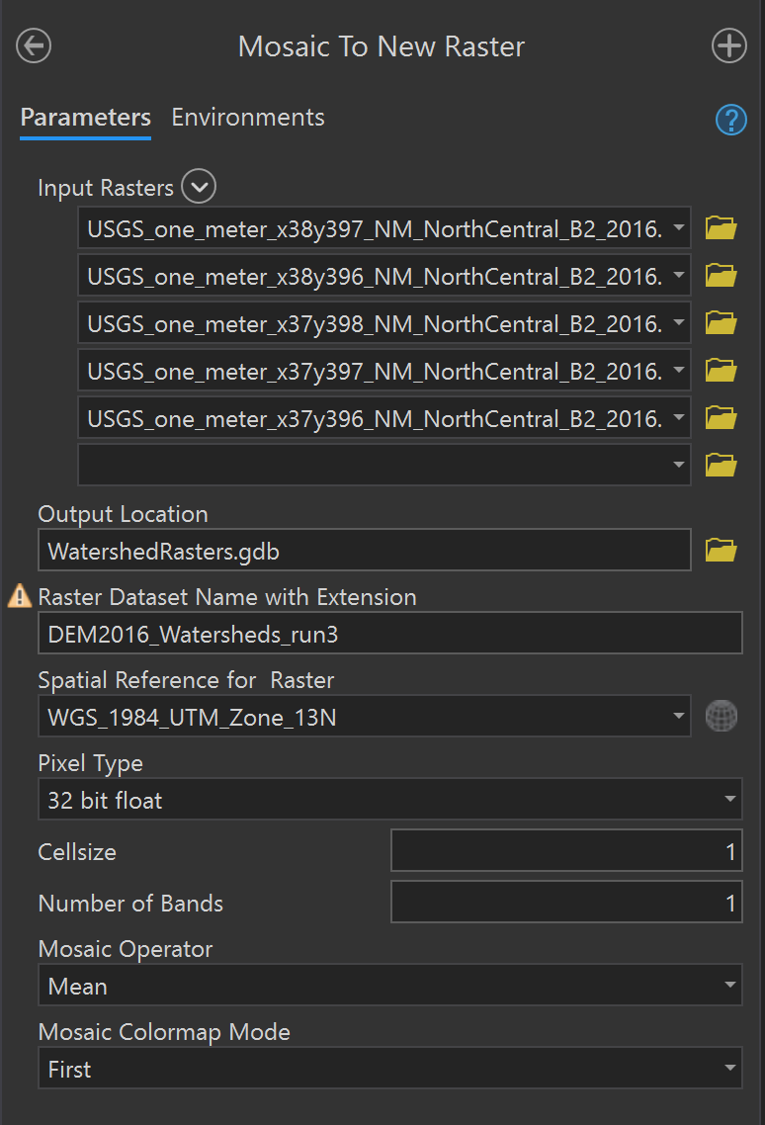

Make sure to change the “Pixel Type” to match the source files (32 bit float). Set “Cellsize” to 1. Output is single raster file, **DEM2016Watersheds_run3**

Fill DEM:

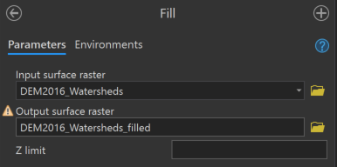

Calculate Flow Direction Raster:

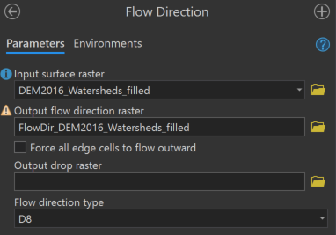

Calculate Flow Accumulation raster:

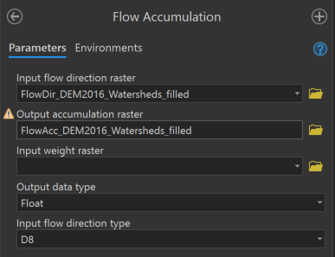

Symbolize Flow Accumulation Raster with classified color ramp so high acc thalwegs are apparent

*Con Flow Accumulation at 50 thousand*

*Stream to feature – to get thalweg do these steps, not done right now*

Create point feature class and manually insert at intersections of thalweg and StreamReach divisions: **PourPoints_manual**

Snap pour points of FrijolesStreamReach markers:

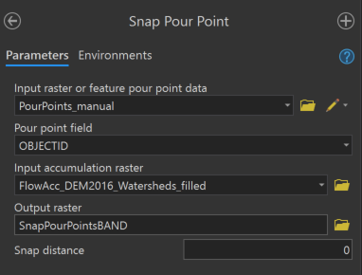

Raster of snapped pour points: **SnapPourPointsBAND**

Calculate watersheds:

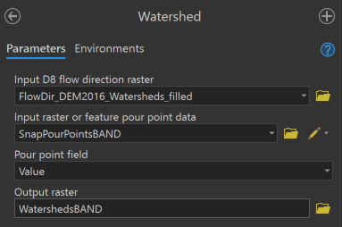

**Convert Raster layer to polygons**

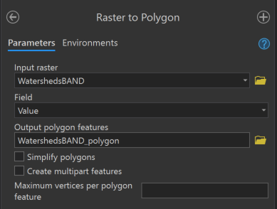

Be sure to uncheck “Simplify polygons”

**Manually “Edit -> Reshape” the lowermost reaches (Frijoles01 and Capulin01) so that they include riparian deltas from BANDBottom layer**

“Dissolve” features by gridcode- polygons like this will be merged with the rest of their watersheds instead of being independent 1 m^2 polygons

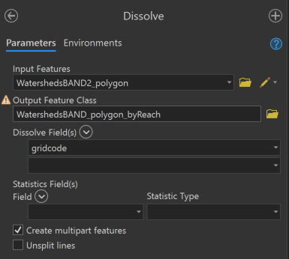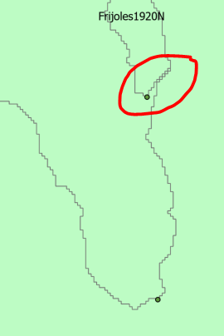

Populate attributes with StreamReach and Canyon (manually)

Final polygon: **WatershedsBAND2_polygon_byReach** (CapulinFrijolesDEM.aprx -> WatershedsAlpha2.gdb)

Split Frijoles and Capulin

Select by attributes -> Canyon = “Frijoles” -> Feature to Feature -> **WatershedsFrijoles_polygon_byReach**

Select by attributes -> Canyon = “Capulin” -> Feature to Feature -> **WatershedsCapulin_polygon_byReach**

Buffer Frijoles

Clip DEMs to extent of buffered polygon